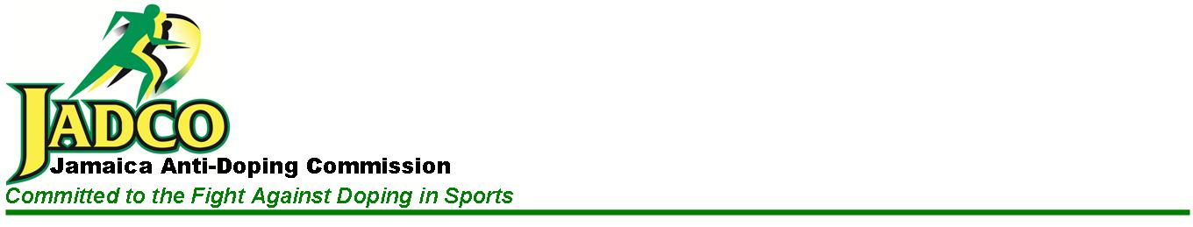
CAREER OPPORTUNITIES

The Jamaica Anti-Doping Commission (JADCO) an agency of the Ministry of Culture, Gender, Entertainment and Sport (MCGES) invites applications from suitably qualified persons to fill the position of Senior Monitoring and Evaluation Officer (GMG/SEG 2) Level 8 (VACANT), in the Compliance Division.

Job Purpose
As part of the Compliance Division assist the Division to achieve its operational objectives by providing timely and efficient monitoring, evaluation and compliance assessment services to the Commission in a timely manner.

Minimum Required Qualifications and Experience
- Bachelor’s Degree from a recognized institution in the disciplines of Management Studies, Business Administration, Public Policy or equivalent.
- Training in Strategic/Corporate Planning, Performance Monitoring and Evaluation would be an asset.
- Knowledge of ISO 9001:2015 Quality Management Systems
- Three (3) years related experience.

Applications accompanied by resumes should be submitted NO LATER THAN
May 15, 2026, addressed to:

Executive Director
Jamaica Anti-Doping Commission
1 Ballater Avenue
Kingston 10

Email: execdirector@jadco.gov.jm

Further details of the post may be obtained from the HRMA Division and the Website of the Jamaica Anti-Doping Commission https://jadco.gov.jm/about-us/careers/).

We thank all for responding, however, only shortlisted applicants will be contacted.

